**PVG’s College of Engineering, Nashik-4**

**Department of Computer Engineering**

**PROJECT SYNOPSIS**

**Title: -** A Real Time Flood Monitoring System and Warning System Via Social

Media using IoT and Wireless Networks.

Academic Year: - 2019-20.

Group ID: - 8

Problem Definition: - To design the flood alert detection and monitoring system using Internet of Things for providing early message regarding upcoming disaster and overcome its causes.

**Aims &Objectives: -**

This flood alert system is basically useful to get idea about flood in forecast to do the sensing of the incoming water level for detection of flood is done by implementing sensors network. In this way water level will be sensed by the sensor and concerned warning messages will be given to the controller then it will take the further action and forward that message via social media platforms like WhatsApp, Instagram, Facebook, twitter, etc. along with the social media platform we are going to send text messages because some of the them maybe don’t have smart phones. Along with the message system a recorded message can be dispatched likewise the cellular companies do to promote their new schemes, so that each person can have warning about the upcoming flood into the river banks.

This system is a system to deliver information in real time

to a user by applying IoT technologies as the monitoring

system. All the data that collected will be transmitted to end

user that installed the application on the smartphone.

This system is a system to deliver information in real time

to a user by applying IoT technologies as the monitoring

system. All the data that collected will be transmitted to end

user that installed the application on the smartphone.

**Relevant Theory: -**

At present, many research works on IoT in disaster domain have been conducted. This section will provide a summary on research works that implement IoT technologies for addressing natural disasters. IoT technologies give benefits in terms of monitoring, tracking, controlling and sensing the environment using real time data. An introduction of the use of IoT to improve environmental monitoring and management tasks [11]. The results from their case study demonstrate that the Integrated Information System (IIS) based on IoT is valuable and efficient for complex tasks in environmental monitoring and management. The use of IoT technologies in tackling the complexity in monitoring the flood specifically using rain gauges [12]. IoT provides an interface for data streaming management in real time and at the back end provide data analysis. In this approach the data collected will be continuously transmitted via the Internet communication infrastructure, to the software components. The software components are designed to compute the stream flow and to quantify the spatial distribution of flood risk. Use of IoT and machine learning based embedded system to predict the probability of floods in a river basin [13].

Some Features we are going to implement in the proposed system are as follows: -

1. We are doing continuous monitoring of the river water level and record its data into relevant database.
2. Also we are monitoring the water level of the dam which is concerned with that particular region or provinces.
3. If due to heavy rain fall into that particular region or continuous rain into that region the administration authority release or discharge the water from the dam (Measures mostly in Cusec and Cumec); Then with the help of proposed system, we can calculate approximate level that is going to up rise into normal water level.
4. When heavy quantity of water discharged from the dam at that time warning message will be delivered to those people who having residence nearby river bank as well as the government authority who is responsible for help and relieve duties like municipal corporation and fire and rescue department.
5. If a consider a situation where a flood zone having active electricity supply or the flood water contains high voltage electricity (greater than 440 volts A.C.) then we deliver a message to the victims as well as the help and rescue department along with the local government like municipal corporation.
6. An advance module we are going to add into proposed system is that we are going to collect acknowledgement from the victims or the people to them we are going to deliver the warning message. Acknowledgement is collected by receiving and measuring the reply message that we have broadcasted. By comparing both data we an easy find out who is trapped into and need evacuation and help.
7. This acknowledgement report is going to submit to government authorities to help them start them relieve operation for the flood victims.
8. An additional module is going to add is to detect land movement to nearby to high climbed or ridge zones to detect landslides. This used to help rescue lives before such disaster occur. Each city contains such kind of zones which needs to monitor on continuous basis. In heavy rainfalls landslides can be occur without any kind of warning and causes very big impact in the form of lives and wealth casualties.
9. If water increases rapidly and it is going higher than he road level of the bridge or the water level goes higher than the bridge then the alert message is delivered that the particular that bridge closed for vehicles andto the government authorities as well as on the social media platforms.
10. When that bridge is closed for vehicle then alter alternate road availability message is going delivered.

Proposed System**: -**

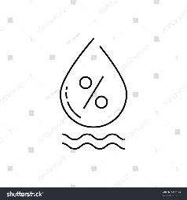  

Rain Measure Sensor Web Application Report Generation

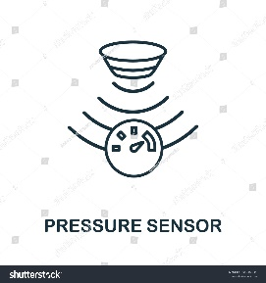 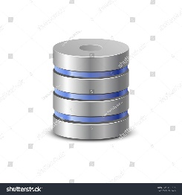 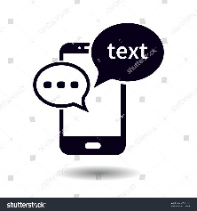

Water Pressure Sensor Database Text Message

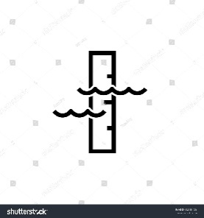 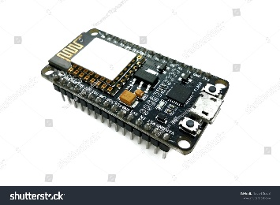 

Water Level Sensor NodeMCU Social Media Notification

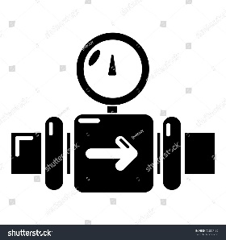 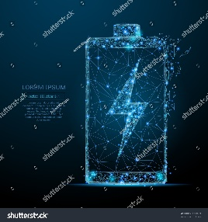 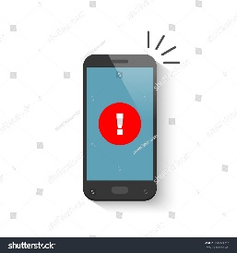

Water flow Sensor Power Supply Voice calling(Optional)

Fig1: Architecture of proposed system

**Working of Social Media Alerts: -**

The Facebook API is a platform for building applications that are available to the members of the social network of Facebook. The API allows applications to use the social connections and profile information to make applications more involving, and to publish activities to the news feed and profile pages of Facebook, subject to individual user’s privacy settings. With the API, users can add social context to their applications by utilizing profile, friend, Page, group, photo, and event data. The API uses RESTful protocol and responses are in JSON format.

We connect the Facebook by using php. We just need to develop the app in facebook to publish the alerts on our timeline.

**Implementation Details (Modules) : -**

* **Hardware module: -**

In this project, some hardware is used that are Microcontroller, sensors, components required for power supply. The Hardware collects the water level, Pressure of water, Rainfall measure to detect the levels of the flood. The hardware consists of Wi-Fi enabled controller which connects to the server and allows to share the data to through internet.

1. Microcontroller- This does the controlling with processing.Microcontroller will take the information from the sensor.This information will have sent to the admin through the database

2. Sensors-This will collect the information from the particular nodes which are located at certain site. There are four sensors we are going to use in this project.

They are as follows:

* Water level measurement: This sensor is used to measure the water level height. For that we are going to use Ultrasonic sensor which emits short, high frequency sound pulses at regular intervals. If they strike an object, then they are reflected back as echo signals to the sensors.
* Rainfall measurement: This sensor is used to measure the average rainfall. For that we are going to use same ultrasonic sensor. Ultrasonic sensor is 4 pin sensor. Those are ground connection (GND), Trigger, echo and last current (VCC).
* Temperature and Humidity: This sensor is used to measure change in atmospheric temperature and humidity. For this we are using DHT11 sensor which works on one wire protocol and gives digital output. Pressure measurement: This sensor is used to determine the atmospheric pressure. For this we are going to useBMP 180Barometric sensor.

3. Power Supply- In real time we get 230v AC, in actual project we do not need this amount of power supply so we convert this AC power supply to DC power supply.

* **Software Module: -**

In this module, we have done an android application as well as the Website application for this project. Admin web page will contain and display the information like Login, Registration, Number of users registered to the app, status of the sensor, safe places near flood affected area where people can migrate and that places are shown on the Map. The Android application will be used by the users who are register. After registration the user can login with aunique username and password. And then user can access all facilities provided by application. Application is provided the information like current status of water level and temperature etc. This app contain map which are show the safe places near the user and also the current place where the user is.

* **Database Module: -**

Microcontroller will send the values measured by the sensors to the server. This will contain the number of users registered to App; this will also show the safe places through the Map. The data uploaded on server is stored on the database. The stored data is then routed to the front end web applications and mobile application

Working of Proposed System:

1. There will be a node as shown in above diagram.
2. This node is the independent flood monitoring node equipped with necessary sensors and connectivity modules.
3. It has three major stages, Including Sensors, Controller, Wi-Fi interface to upload the information on server.
4. Data from various sensors are collected by the ESP and is then computed and uploaded on the server.
5. The data uploaded on server is stored on the database.
6. The stored data is then routed to the front end web applications and mobile applications.

**Minimum Requirement: -**

1. Software: -

* PhpMyadmin
* Ardiuno IDE
* LUA Programming
* Google Geolocation API
* Facebook Developers API
* HTML, CSS
* Google API

1. Hardware:
2. Real time can detect water increase in three
3. levels.
4. •Can process digital and analog signal into
5. useful information.
6. •Low power consumption
7. •Availability use width range network
8. technology
9. •Scalable can expands network architecture

* NodeMCU ESP8266 12E

# DHT11 Temperature & Humidity Sensor

#### DHT11 is a basic Temperature & Humidity Sensor module with digital output at low cost. It uses thermistor to measure the surrounding air temperature and a capacitive humidity sensor to measure the moisture content. It sends digital readings on data pin so there is no need to use an Analog to Digital Converter (ADC) chip.

* Ultrasonic Sensor

Ultrasonic Distance Sensor provides very short (2CM) to long-range (4M) detection and ranging. The sensor provides precise and stable non-contact distance measurements from about 2cm to 4 meters with very high accuracy. It can be easily interfaced to any node mcu, Arduino, Raspberry Pi or any other micro controller. This ultrasonic sensor module can be used for measuring distance, object sensor, motion sensors etc. High sensitive module can be used with microcontroller to integrate with motion circuits to make distance, position & motion sensitive products.

The module sends eight 40Khz square wave pulses and automatically detects whether it receives the returning signal. If there is a signal returning, a high level pulse is sent on the echo pin. The length of this pulse is the time it took the signal from first triggering to the return echo.

* Water Flow Sensor

This is used when water flow through the rotor, rotor rolls. It’s speed changes with different rate of flow. The half-effect sensor outputs the corresponding pulse signal.

* Water Level Sensor

This is a low cost easy to use Water Level Sensor. This water level sensor has a series of parallel exposed traces to measure droplets/water volume in order to determine the water level. Very Easy to monitor water level as the output to analog signal is directly proportional to the water level. This output analog values can be directly read via ADC and can also be connected directly microcontrollers input pins.

**Specifications of Water Level Sensor Module**

* Working Voltage: DC 3-5V
* Working Current: <20mA
* Sensor Type: Simulation
* Detection Area: 40 mm x 16 mm
* Size: 65 mm x 20 mm x 8 mm

**Application: -**

1. Municipal Corporations: -

The Municipal Corporation has The Emergency Response Team which faces natural and human involved disasters. By using proposed system an automated message is going to deliver to those Respond Teams to help victims.

1. Fire Department: -

The Fire Department is responsible to help the victims who are trapped into such flood situation where they can have at least information regarding upcoming disaster which going to prevent human casualties.

1. Smart City Management : -

If such ideas included into smart city development then it could improve the impression of that city over other cities regarding early warning relive support.

**Conclusion:**

The success of flood disaster management depends largely on how well flood related data can be collected, managed and utilized. Due to this importance, the use of IoT to facilitate flood data management is seen as a step in the right direction. Many researchers have started to utilize the IoT concept in their work on flood disaster. However, to ensure that all these works that make use of IoT can later be integrated and used together, it is important to have a common architecture that specifies how the different components fit within the larger system and interact with each other. This paper proposed an IoT architecture to serve this purpose. With the proposed architecture, future research works on flood that makes use of IoT will have a reference to specify how the work can fit within the larger flood management system.

**References:**

1. Alphonsa, A., and Ravi, G. (2016). Earthquake early warning system by IOT using Wireless sensor networks. Paper presented at the Wireless Communications, Signal Processing and Networking (WiSPNET), International Conference on, 1201-1205.

2. Amendola, S., Lodato, R., Manzari, S., Occhiuzzi, C., and Marrocco, G. (2014). RFID technology for IoT-based personal healthcare in smart spaces. IEEE Internet of Things Journal, 1(2), 144-152.

3. Atzori, L., Iera, A., and Morabito, G. (2010). The internet of things: A survey. Computer networks, 54(15), 2787-2805.

4. Catarinucci, L., De Donno, D., Mainetti, L., Palano, L., Patrono, L., Stefanizzi, M. L., et al. (2015). An IoT-aware architecture for smart healthcare systems. IEEE Internet of Things Journal, 2(6), 515-526.

5. Chen, X.-Y., and Jin, Z.-G. (2012). Research on key technology and applications for internet of things. Physics Procedia, 33, 561-566.

6. Christin, D., Reinhardt, A., Mogre, P. S., and Steinmetz, R. (2009). Wireless sensor networks and the internet of things: selected challenges. Proceedings of the 8th GI/ITG KuVSFachgesprächDrahtlosesensornetze, 31-34.

7. Deak, G., Curran, K., Condell, J., Asimakopoulou, E., and Bessis, N. (2013). IoTs (Internet of Things) and DfPL (Device-free Passive Localisation) in a disaster management scenario. Simulation Modelling Practice and Theory, 35, 86-96.

8. Dersingh, A. (2016). Design and development of a flood warning system via mobile and computer networks. Paper presented at the Electronics, Information, and Communications (ICEIC), 2016 International Conference on, 1-4.

9. Dlodlo, N., and Kalezhi, J. (2015). The internet of things in agriculture for sustainable rural development. Paper presented at the Emerging Trends in Networks and Computer Communications (ETNCC), 2015 International Conference on, 13-18.

10. Doukas, C., and Maglogiannis, I. (2012). Bringing IoT and cloud computing towards pervasive healthcare. Paper presented at the Innovative Mobile and Internet Services in Ubiquitous Computing (IMIS), 2012 Sixth International Conference on, 922-926.

11. Dubey, R., Luo, Z., Xu, M., and Wamba, S. F. (2015). Developing an Integration Framework for Crowdsourcing and Internet of Things with Applications for Disaster Response. Paper presented at the Data Science and Data Intensive Systems (DSDIS), 2015 IEEE International Conference on, 520-524.

12. Fang, S., Da Xu, L., Zhu, Y., Ahati, J., Pei, H., Yan, J., et al. (2014). An integrated system for regional environmental monitoring and management based on internet of things. IEEE Transactions on Industrial Informatics, 10(2), 1596-1605.

13. Gangopadhyay, S., and Mondal, M. K. (2016). A wireless framework for environmental monitoring and instant response alert. Paper presented at the Microelectronics, Computing and Communications (MicroCom), 2016 International Conference on, 1-6.

14. Giorgetti, A., Lucchi, M., Tavelli, E., Barla, M., Gigli, G., Casagli, N., et al. (2016). A robust wireless sensor network for landslide risk analysis: system design, deployment, and field testing. IEEE Sensors Journal, 16(16), 6374-6386.

15. Goel, S. (2006). Encyclopaedia of Disaster Management: Disaster management, policy, and administration: Deept & Deep Publications

**Group members Information: -**

|  |  |  |  |
| --- | --- | --- | --- |
| Sr.No | Name of the Group Members | Date | Sign |
| 1 | Mast. Mayur Tajane. | 23-7-2019 |  |
| 2 | Mast. Harshal Chaudhari. | 23-7-2019 |  |
| 3 | Miss. Monali Sonawane. | 23-7-2019 |  |
| 4 | Miss. Mayuri Sonavane. | 23-7-2019 |  |

**Project Guide Project Co-ordinator H.O.D.**

(Prof. J.Y. Kapdnis.) (Prof. M.T. Jagtap.) (Prof. J.Y. Kapdnis.)